1.What is bug In Software Testing?
A bug is a fault in a program which causes it to behave abruptly. A software bug is : An error, flaw, failure or fault in a computer program or system that causes it to produce an incorrect or unexpected result.
In Software testing, when the expected and actual behavior is not matching, an incident needs to be raised. An incident may be a Bug. It is a programmer's fault where a programmer intended to implement a certain behavior, but the code fails to correctly conform to this behavior because of incorrect implementation in coding.
Defect accepted by the development team then it is called Bug.

2.Differentiate Error, Defect, And Failure?
Error: We can’t compile or run a program due to coding mistake in a program. If a developer is unable to successfully compile or run a program then they call it an error. Any human mistake in the code is called an error.
Defect: It can be simply defined as a variance between expected and actual. Defect is an error found AFTER the application goes into production. In other words, defect is the difference between expected and actual result in the context of testing. It is the deviation of the customer requirement.
Failure: Once the product is deployed and customers find any issues then they call the product as a failure product. After release, if an end user finds an issue then that particular issue is called a failure.

3.What Are The Different Types Of Status Of Defects?
The different types of status of a defect are:
New: An error has been found in the developed product, and it is seen as deviating the expected output from the actual output.
IT Committed: The error is recognised as a defect and reported to the development team.
Development: The development team accepts the defect and works on fixing it.
Ready for QA: The development team fixes the defect and marks it for the QA team to test it.
In-Testing: The QA team tests the fixed defect.
Testing Successfully Completed: If the defect is resolved and the actual output is same as the expected output, the testing of that defect completes.

4.Explain About Defect/Bug Life Cycle?

- New: When a defect is logged and posted for the first time. It’s state is given as new.
- Assigned: After the tester has posted the bug, the lead of the tester approves that the bug is genuine and he assigns the bug to corresponding developer and the developer team. It’s state given as assigned.
- Open: At this state the developer has started analyzing and working on the defect fix.
- Fixed: When a developer makes necessary code changes and verifies the changes then he/she can make bug status as ‘Fixed’ and the bug is passed to the testing team.
- Pending retest: After fixing the defect the developer has given that particular code for retesting to the tester. Here the testing is pending on the testers end. Hence its status is pending retest.
- Retest: At this stage the tester does the retesting of the changed code which the developer has given to him to check whether the defect got fixed or not.
- Verified: The tester tests the bug again after it got fixed by the developer. If the bug is not present in the software, he approves that the bug is fixed and changes the status to “verified”.
- Reopen: If the bug still exists even after the bug is fixed by the developer, the tester changes the status to “reopened”. The bug goes through the life cycle
- Closed: Once the bug is fixed, it is tested by the tester. If the tester feels that the bug no longer exists in the software, he changes the status of the bug to “closed”. This state means that the bug is fixed, tested and approved.
- Duplicate: If the bug is repeated twice or the two bugs mention the same concept of the bug, then one bug status is changed to “duplicate“.
- Rejected: If the developer feels that the bug is not genuine, he rejects the bug. Then the state of the bug is changed to “rejected”.
- Deferred: The bug, changed to deferred state means the bug is expected to be fixed in next releases. The reasons for changing the bug to this state have many factors. Some of them are priority of the bug may be low, lack of time for the release or the bug may not have a major effect on the software.
- Not a bug: The state given as “Not a bug” if there is no change in the functionality of the application. For an example: If a customer asks for some change in the look and feel of the application like change of colour of some text then it is not a bug but just some change in the look of the application.

5. A bug is identified by the tester it is assigned to whom?
Once the defect is logged by the tester, the test lead or developer approves that the bug is valid then it will get assigned to the developer team.

6.Why is JIRA used? Explain step by step how an issue is created in JIRA.
Jira is a proprietary issue tracking product developed by Atlassian which allows bug tracking and agile project management.
It is used for bug tracking, issue tracking, and project management.
Issue
An issue represents an action that has to be done. That action can be a task, a bug, a feature request or any type of action your organization might need to work with. Issues are the core of the Jira applications since all the team collaboration happens around the work items and their organization.
Add a new issue type
- Select the Jira icon > Jira settings > Issues.
- Click Issue types > Add issue type.
- Enter a name and description for your new issue type.
- Choose between a standard or sub-task issue type. Sub-tasks can be used for smaller pieces of work that are associated with a standard issue.
- Click Add.

7.What is Defect Density?
Defect Density is the number of confirmed defects detected in software/component during a defined period of development/operation divided by the size of the software/component.
The ‘defects’ are:
- confirmed and agreed upon (not just reported).
- Dropped defects are not counted.
The period might be for one of the following:
- for a duration (say, the first month, the quarter, or the year).
- for each phase of the software life cycle.
- for the whole of the software life cycle.

Defect Density = Defect count/ size of the release

Uses:
- It enables one to decide if a piece of software is ready to be released.
- For comparing the relative number of defects in various software components so that high-risk components can be identified and resources focused towards them.
- For comparing software/products so that quality of each software/product can be quantified and resources focused towards those with low quality.

8.What is the difference between defect density and defect triage?
Defect Density
- Defect Density is the number of confirmed defects detected in software/component during a defined period of development/operation divided by the size of the software/component.
- It enables one to decide if a piece of software is ready to be released.

Defect Triage
- Defect triage is a process where each bug is prioritized based on its severity, frequency, risk, etc. Triage term is used in the Software testing / QA to define the severity and priority of new defects.
- The goal of Bug Triage is to evaluate, prioritize and assign the resolution of defects. The team needs to validate severities of the defect, make changes as per need, finalize resolution of the defects, and assign resources. Mainly used in agile project management.

9.Explain Bug reporting and parameters of bug?
A bug report is actually one of the phases of product testing. The developers usually write bug reports after the bug was detected. The main task of these reports is to document the bugs and avoid their reappearance in the future. Bug reports also help the developers track bugs.
- An effective bug report communicates well with the development team and avoids miscommunication.
- A good bug report should be clear and concise without missing key points.
- Report each bug as a separate issue.
- In case of multiple issues in single bug report, you can’t close it unless all the issues are resolved.
- Hence it is best to split the issues into separate bugs. This ensures that each bug can be handled separately.
Parameters of a bug:
- Defect ID - Unique identification number for the defect.
- Defect Summary/Title - It must be clear and descriptive, so that you get an idea of what it is about at a glance.
- Defect Description - Detailed description of the Defect including information about the module in which Defect was found. It helps the developer to understand the Defect. It is a good practice to separate each problem separately instead of crumbling them altogether. Don’t use terms like “I think” or “I believe”. It must include Steps to Reproduce with proper Screenshots along with Expected and Actual result.
- Version - Environment/Browser Version in which defect was found.
- Date Raised - Date when the defect is raised
- Detected By - Name/ID of the tester who raised the defect
- Status - Status of the defect
- Assignee - Name of the developer whom it is assigned to fix
- Severity which describes the impact of the defect on the application
- Priority which is related to defect fixing urgency.

10.What is defect management? Explain the defect management process.
Defect Management is a systematic process to identify and fix bugs. A defect management cycle contains the following stages:
1) Discovery of Defect
2) Defect Categorization
3) Fixing of Defect by developers
4) Verification by Testers
5) Defect Closure
6) Defect Reports at the end of project
Discovery
In the discovery phase, the team has to discover as many defects as possible, before the Release/Go live of the project. A defect is said to be discovered and change to status accepted when it is acknowledged and accepted by the developers.
Categorization
Defect categorization helps software developers to prioritize their tasks. That means that this kind of priority helps the developers in fixing those defects first that are highly crucial.
Resolution
Once the defects are accepted and categorized they are fixed by the developer.
Verification
After the development team fixed the reported issues, the testing team verifies them.
Closure
Once a defect has been resolved and verified, the defect is closed.
Reporting
Current defect situation is reported.

11.What is Test estimation? Explain Work Breakdown Structure test estimation technique with an example?
Test Estimation is a management activity which approximates how long a Task would take to complete.
Estimating effort for the test is one of the major and important tasks in Test Management.
Work Breakdown Structure Test Estimation
Work Breakdown Structure (WBS), in Project Management and Systems Engineering, is a deliverable-oriented decomposition of a project into smaller components. WBS is a key project deliverable that organizes the team's work into manageable sections. The Project Management Body of Knowledge (PMBOK) defines WBS as a "deliverable oriented hierarchical decomposition of the work to be executed by the project team."
- Divide the whole project task into subtasks
- Use the Work BreakDown structure to break out the project into 5 smaller tasks
- After that, you can break out each task to the subtask. The purpose of this activity is to create tasks as detailed as possible.
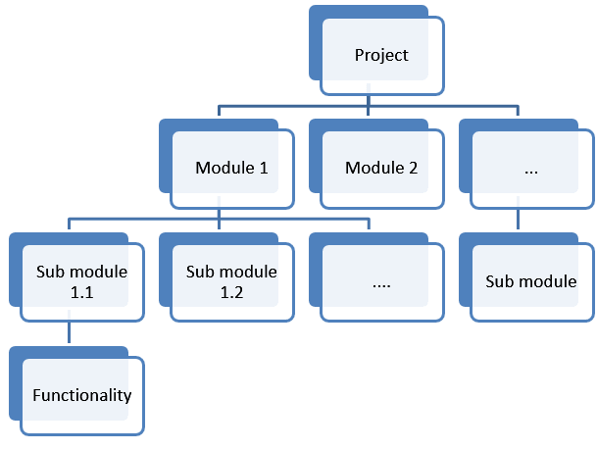

12.What are test reports? What parameters are used in test reports?
Test summary report /Quality Reports is a document which contains summary of test activities and final test results.
Parameters used in Test Report:
- A summary of test activities and final test results.
- An assessment of how well the Testing is performed.
Based on the test report, the stakeholders can Evaluate the quality of the tested product. Make a decision on the software release.

13.What are the test management tools?
Test management tools are used to store information on how testing is to be done, plan testing activities and report the status of quality assurance activities. The tools have different approaches to testing and thus have different sets of features.
Different test management tools are:

TestLink:
- Test-link is the most widely used web based open source test management tool.
- It synchronizes both requirements specification and test specification together.
- User can create test project and document test cases using this tool.
- With Test-Link you can create an account for multiple users and assign different user roles.
- Admin user can manage test cases assignment task.
JIRA:
- Jira is a proprietary issue tracking product developed by Atlassian which allows bug tracking and agile project management.
- It is used for bug tracking, issue tracking, and project management.

14.What is a test link? How do you write test cases in TestLink?
TestLink:
- Test-link is the most widely used web based open source test management tool.
- It synchronizes both requirements specification and test specification together.
- User can create test project and document test cases using this tool.
- With Test-Link you can create an account for multiple users and assign different user roles.
- Admin user can manage test cases assignment task.
Following are the steps to create a Test Case −
Step 1 − Navigate to Test Specification → Test Specification from the dashboard.
Step 2 − Select the test suite from the tree structure on the left side panel on the screen.
Step 3 − Click the Setting type icon known as Actions on this page, present on the right panel of the screen as shown below.
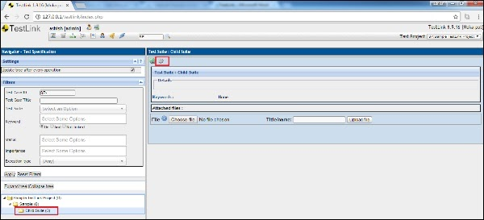
It will open Test Suite Operations as well as Test Case Operations.
Step 4 − Click the + icon of Test Case Operations to create a new test case as shown below.
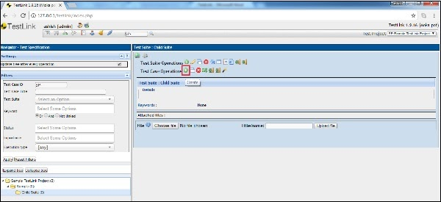
It opens the create test case page.
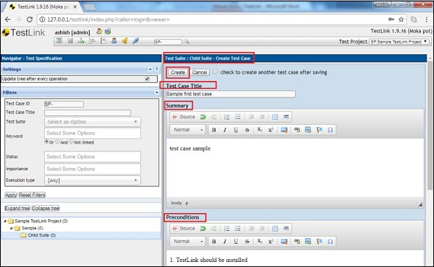
Step 5 − Enter the following fields in the form −
- Name of Test Case
- Summary
- Pre-conditions
- Select Status, Importance and Execution type
- Enter the estimated execution type in minutes
- Keywords − It displays all the available keywords. You can assign them based on the relation.
Step 6 − Click the Create button as displayed in the following screenshot.

Once you click the Create button, you can see the test case in the tree structure on the left side panel as well as the details are available on the right side of the screen.
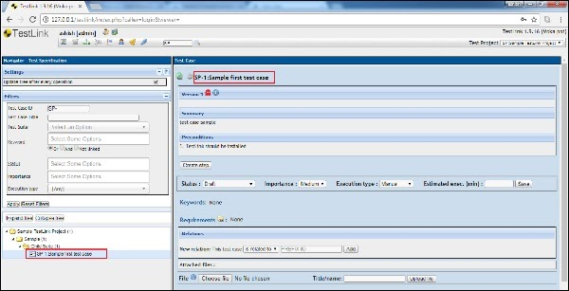

15.Explain steps how to upload Test case sheet on TestLink?

Import a Test Suite
Step 1 − To import the test suite, go to Test Specifications → Test Specification from the dashboard.
Step 2 − Select the project and the folder on the left pane where you want to import the test suite.
OR
To import only test cases, select the nearest test suite folders where the test cases should be imported.
Step 3 − Click the Actions icon on the right pane as shown below.

It displays the test suite operations.
Step 4 − Click the Import icon as shown below −
OR
To upload only test cases, click the Import icon present in Test Case Operations (below the Test Suite Operations).

It opens the Import Test Suite page. By default, the file type is selected as XML.
Step 5 − Fill in the following details −
- File − Select the XML file and upload it. Max size of the file should be 400KB.
- Consider test case as duplicate if: Select the appropriate option from the list.
- Action for duplicate: Select the appropriate option from the list.
Step 6 − Click the Upload file button as shown below −

Step 7 − After import, a successful message is displayed as shown below.
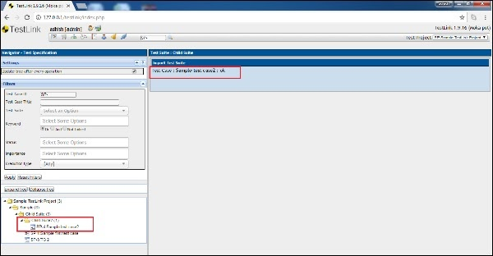

16.What is severity and priority in bug/defect?
Severity
- Severity is defined as the degree of impact a Defect has on the development or operation of a component application being tested.
- Higher effect on the system functionality will lead to the assignment of higher severity to the bug
- Defect severity can be categorized into four class (Blocker,Critical, Major, Minor, Trivial)
- Severity status is based on the technical aspect of the product
- Severity indicates the seriousness of the defect on the product functionality
Severity can be of following types:
- Critical: This defect indicates complete shut-down of the process, nothing can proceed further
- Major: It is a highly severe defect and collapses the system. However, certain parts of the system remain functional
- Medium: It causes some undesirable behavior, but the system is still functional
- Low: It won't cause any major break-down of the system
Priority
- Priority is defined as the order in which a defect should be fixed.
- Higher the priority the sooner the defect should be resolved.
- Defects that leave the software system unusable are given higher priority over defects that cause a small functionality of the software to fail.
- Defect priority can be categorized as (Low, Medium, High)or P0,P1 and P2.
- Priority status is based on the customer requirements
Priority can be of following types:
- High: Must be fixed in any of the upcoming builds but should be included in the release.
- Medium: May be fixed after the release / in the next release.
- Low: May or may not be fixed at all.
Severity and priority can be clubbed together as:
- Low priority, high severity
- Low priority, low severity
- High priority, Low severity
- High priority, High severity
17. While placing an order for clothing website, in order confirmation page there is a logo error. It is a?
  - High priority, high severity
  - Low severity low priority
  - Low severity, high priority (of low severity as it not going to affect the functionality of the website but can be of high priority as you don't want any further shipment to proceed with the wrong logo.)
  - High severity low priority
18. Website home page failed to load.
- High priority, high severity (Major functionality failure like log in is not working, crashes in the basic workflow of the software are the best example of High Priority and High Severity)
- Low severity low priority
- Low severity, high priority
- High severity low priority
19. The application works perfectly for 50k sessions but beings to crash after a higher number of sessions.
  - Low severity low priority
  - High priority, high severity
  - Low severity, high priority
  - High severity low priority (This problem needs to be fixed but not immediately.)
20. An application (web) is made up of 20 pages. On one of the pages, there is a sentence with a grammatical error.
- Low severity low priority - This bug may go unnoticed to the eyes of many and won't affect any functionality or the credibility of the company.
- High priority, high severity
- Low severity, high priority
- High severity low priority
21.Find bugs and report the same on JIRA for below-mentioned modules in the website: http://www.rushplace.com/ : Testwebsite1
1.My Account
- No Sign-up module in my account section only Login module.
- Lost Password section operates with invalid email-id.
2. Add to basket
- No shipping available on even valid addresses.
- Invalid personal details are also accepted.
- Invalid PinCode are also accepted.
- Invalid Phone No are also accepted.
- Invalid Email id are also accepted.
- No payment
3.Search
- Search button not operational

22.Find bugs and report the same on JIRA for below-mentioned modules in the website: http://newtours.demoaut.com/mercurywelcome.php : Testwebsite2
1.Register Here
- Top header navigation options
- UI bugs for the complete website.
- 1.Register here:
- Able to register with numeric characters and special symbols.
- Able to register with all fields blank.
- Able to register without password confirmation.
- Able to register with invalid address details.
- Able to register with invalid contact information.
- Able to register with invalid mailing information.
- Able to register with invalid user information.
2. Top header navigation options
- Contact Option in header section is not available i.e. under construction.
- Support Option in the header section is not available i.e. under construction.
- Able to sign-on with invalid username and Password.
3. UI bugs for the complete website.
- Display of website is not according to the screen dimensions.
- Header navigation options are not responsive.
- Links are not Interactive.

23.Write Test Cases for Amazon login, Sign up and Forgot password on TestLink.

https://docs.google.com/spreadsheets/d/1mciJMNQi6wE1pbkSP9rL0CYkfzqPQ_M9-Ibb12dA5vw/edit#gid=2006205776
Sheet 1

24.Write Test Cases for placing an order in Myntra on TestLink.
https://docs.google.com/spreadsheets/d/1mciJMNQi6wE1pbkSP9rL0CYkfzqPQ_M9-Ibb12dA5vw/edit#gid=2006205776
Sheet 2

25.Write Test Cases for Search functionality on TestLink.
https://docs.google.com/spreadsheets/d/1mciJMNQi6wE1pbkSP9rL0CYkfzqPQ_M9-Ibb12dA5vw/edit#gid=2006205776
Sheet 3

